SMART
Items: 6 Steps (Including Introduction)
Duration: 30 seconds
Filename: G:\OntarioLearn\SMART .intr

5 seconds
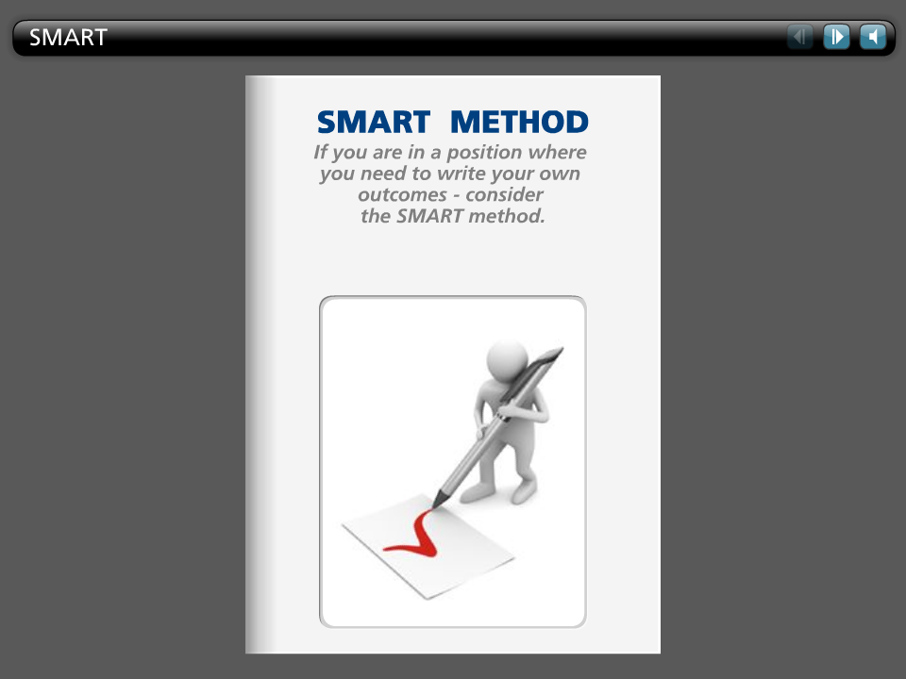

Step Text
SMART METHOD

If you are in a position where
you need to write your own
outcomes - consider
the SMART method.

5 seconds
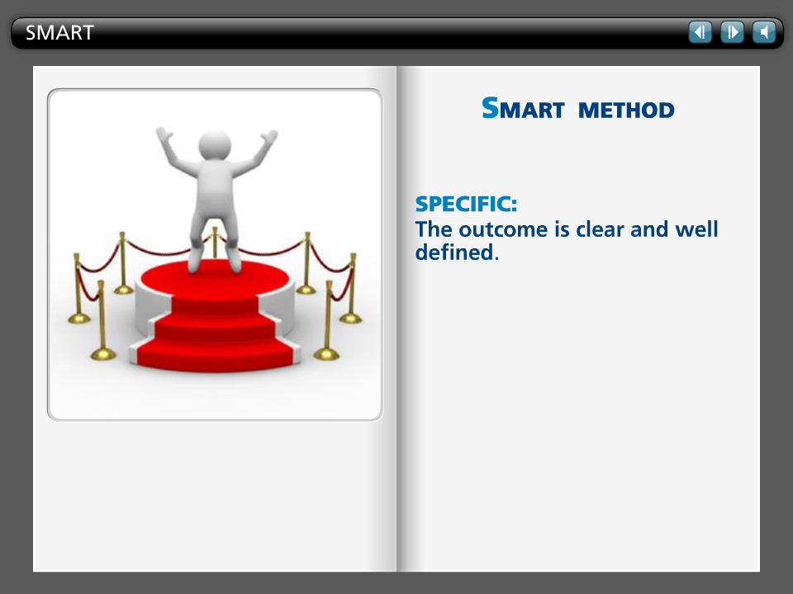

Step Text
SMART METHOD

SPECIFIC:

The outcome is clear and well defined.

5 seconds
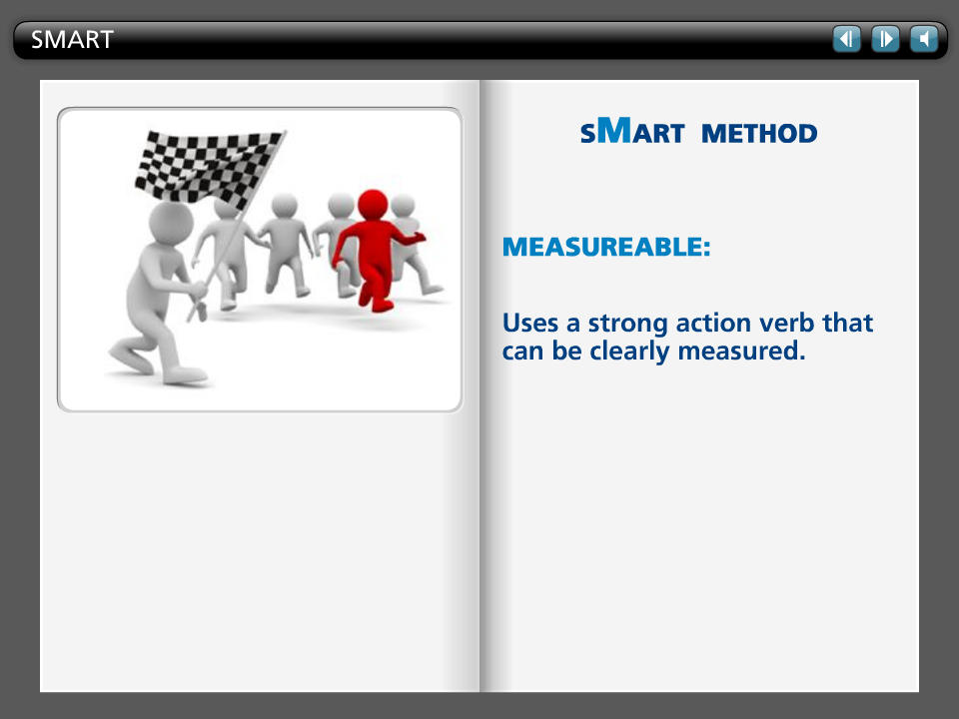

Step Text
SMART METHOD

MEASUREABLE:

Uses a strong action verb that can be clearly measured.

5 seconds
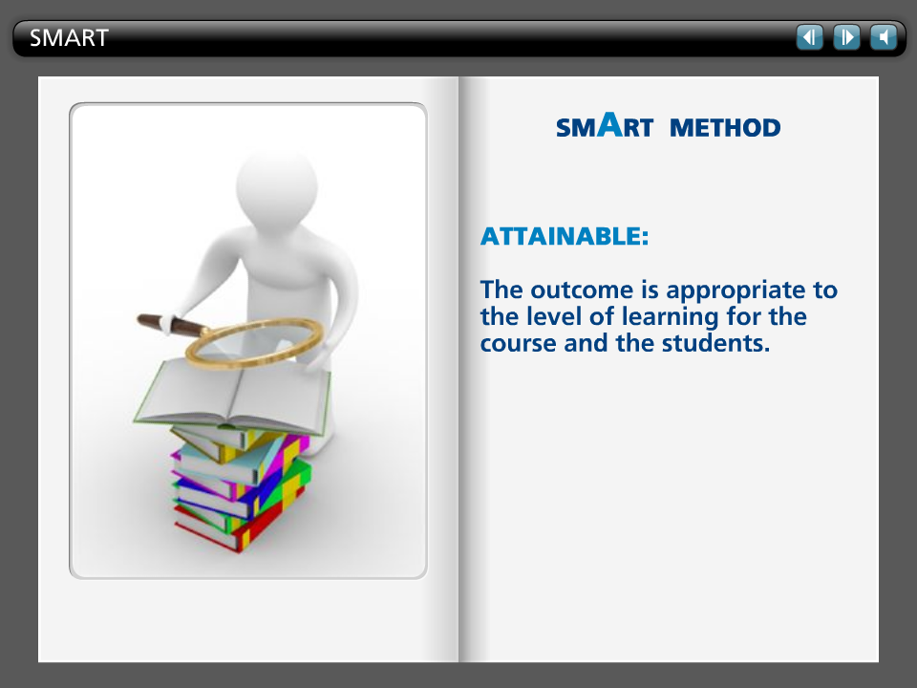

Step Text
SMART METHOD

ATTAINABLE:

The outcome is appropriate to the level of learning for the course and the students.

5 seconds
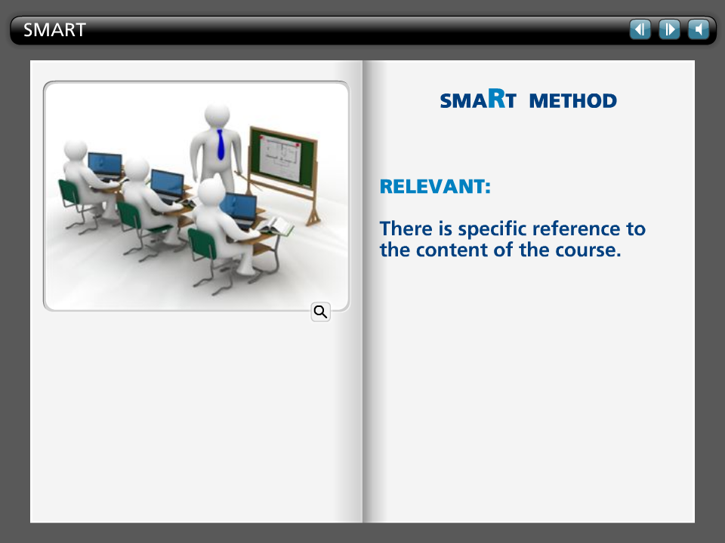

Step Text
SMART METHOD

RELEVANT:

There is specific reference to the content of the course.

5 seconds
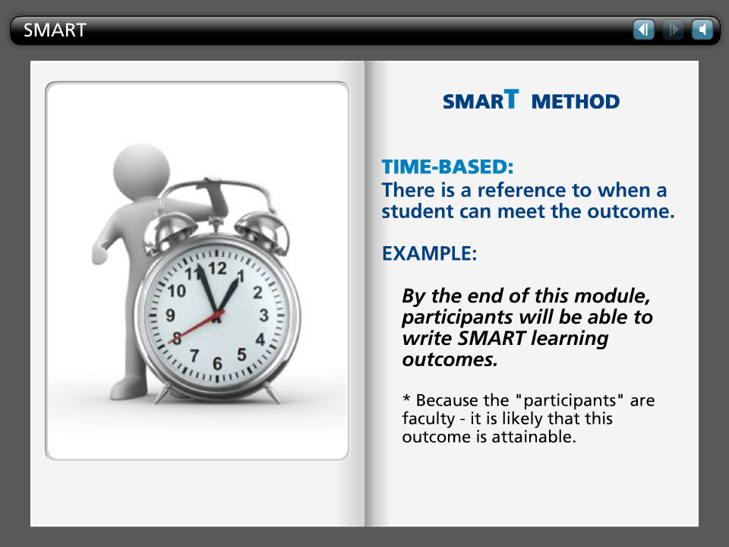

Step Text
SMART METHOD

TIME-BASED:

There is a reference to when a student can meet the outcome.

EXAMPLE:

By the end of this module, participants will be able to write SMART learning outcomes.

* Because the "participants" are faculty - it is likely that this outcome is attainable.

